King Saud University

College of Computer and Information Sciences

Department of Software Engineering

<online diary >

SWE-444

Team Members

Saleh AlShehri (436108011)

Mohammed AlMarhom (439101984)

Project Report

Date:17/04/22

Table of Contents

Introduction 4

About the project 4

Domain 4

Goals 4

Objectives 4

Main Features 4

Target Audience 4

Actors / Stakeholders 5

User Stories 5

Plan 5

Design Documents 6

All Sprint Reports 9

Sample Code 15

Testing Information 17

Deployment 19

Screen Shots 19

Sprint Board 19

User Interface 21

List of figures

Figure 1: Project Roadmap Plan 7

Figure 2: Online Diary Use Case Diagram 8

Figure 3: Write and Save Diary Activity Diagram 9

Figure 4: Delete Diary Activity Diagram 10

Figure 5: Burndown Chart of Sprint 1 12

Figure 6: Burndown Chart of Sprint 2 13

Figure 7: Burndown Chart of Sprint 3 14

Figure 8: Burndown Chart of Sprint 4 16

Figure 9: Sample Code of Sign in Using Google API 17

Figure 10: Sample Code of Write Notes 17

Figure 11: Sample Code of view notes 18

Figure 12: Board of Sprint 1 21

Figure 13: Board of Sprint 2 22

Figure 14: Board of Sprint 3 22

Figure 15: Board of Sprint 4 23

Figure 16: Main Page 23

Figure 17: Log in Page Interface 24

List of tables

Table 1: Roles of Sprint 1 11

Table 2: Sprint 1 Overview 11

Table 3: Sprint 1 Backlog 12

Table 4: Sprint 1 List of Deliverables 12

Table 5: Roles of Sprint 2 13

Table 6: Sprint 2 Overview 13

Table 7: Sprint 2 Backlog 13

Table 8: Sprint 2 List of Deliverables 14

Table 9: Roles of Sprint 3 14

Table 10: Sprint 3 Overview 14

Table 11: Sprint 3 Backlog 15

Table 12: Sprint 3 List of Deliverables 15

Table 13: Roles of Sprint 4 15

Table 14: Sprint 4 Overview 15

Table 15: Sprint 4 Backlog 16

Table 16: Sprint 4 List of Deliverables 16

Table 17: Test Case of Login from Sprint 1 19

Table 18: Test Case of Write Diary from Sprint 2 19

Table 19: Test Case of Save Diary from Sprint 2 20

Table 20: Test Case of Edit Old Diary from Sprint 3 20

Table 21: Test Case of Delete Old Diary from Sprint 4 20

Table 22: Test Case of Sign in with Google API from Sprint 4 20

# Introduction

## About the project

This project has a simple idea, it is a website that reminds you of tasks, meetings, and another agenda.

## Domain

This project aims to help any user who wants to arrange their reminders of tasks, meetings, and scheduling other future agendas.

## Goals

This project aims to help the users:

1. Organize time.
2. Set Reminders.
3. Schedule future agendas.

## Objectives

1. The Project will be delivered on time with the agile methodology.
2. All user stories will be implemented.

## Main Features

The user should be able to:

1. Add new notes to the agenda.
2. Save the notes.
3. View old notes.
4. Edit old notes.
5. Delete notes.

## Target Audience

Students, Doctors, Professors, Businessmen, Managers, Staff, … etc.

# Actors / Stakeholders

User

Scrum team

# User Stories

-sprint 1: register – log in/log out

-sprint 2: write diary - save diary- view old diary

-sprint 3: search diary - edit old diary

-sprint 4: sign in with google account - delete old diary

# Plan

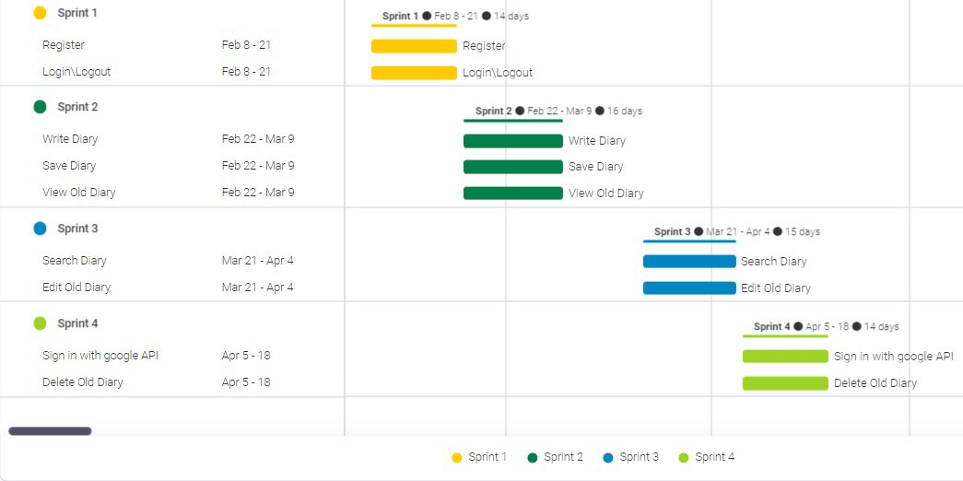

Figure 1: Project Roadmap Plan

# Design Documents

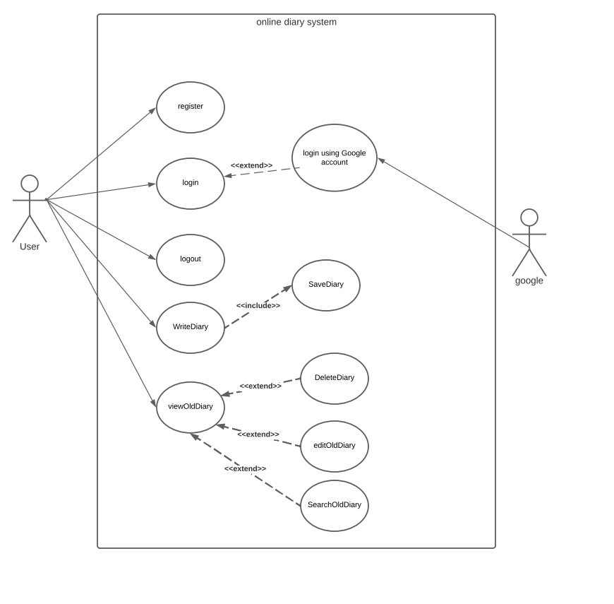

Figure 2: Online Diary Use Case Diagram

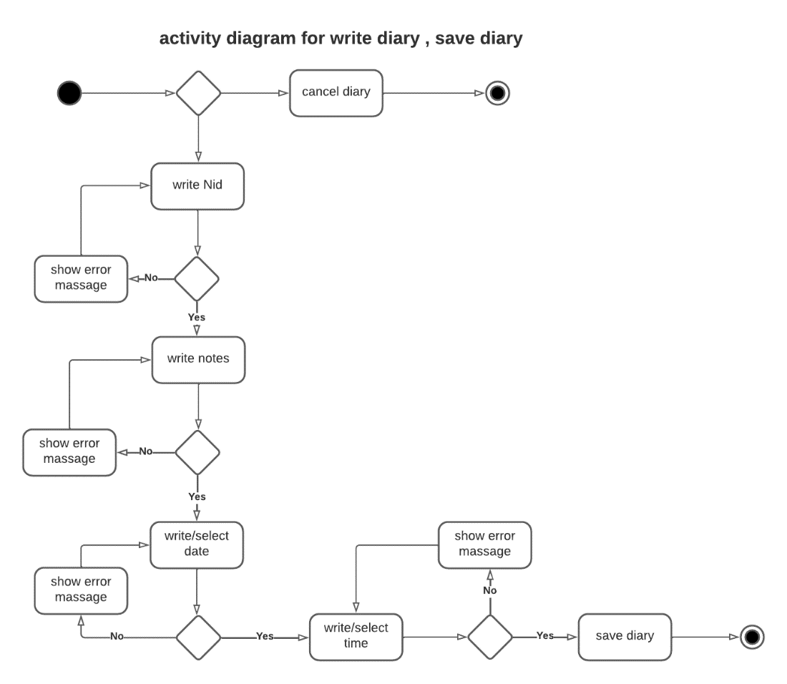

Figure 3: Write and Save Diary Activity Diagram

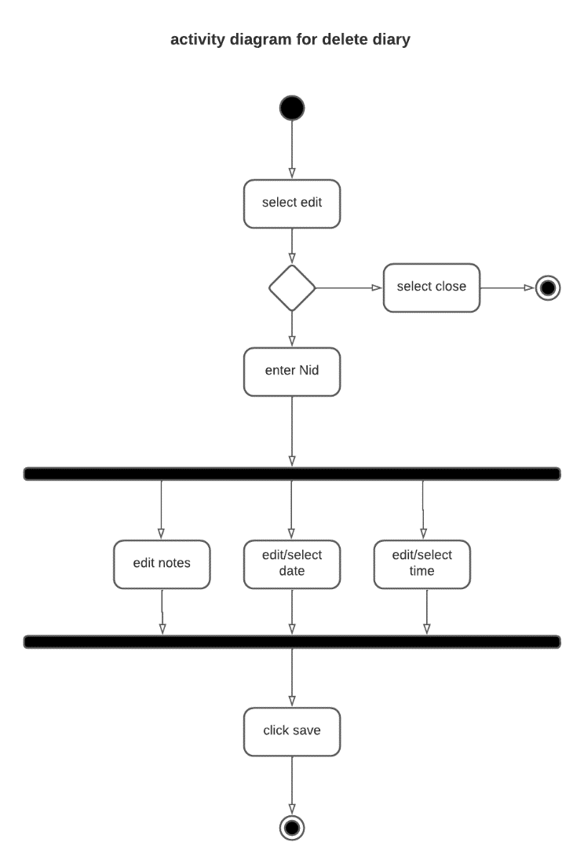

Figure 4: Delete Diary Activity Diagram

# All Sprint Reports

Sprint: 1#

|  |  |  |
| --- | --- | --- |
| Role | Name | Hours- ( Spent / Estimated) |
| Scrum Master | Saleh | 27/20 |
| Product owner | AlMarhom | 0/0 |
| Team member | AlMarhom | 27/20 |
| Team member | AlKhelb | 6/20 |

Date from 8/2/2022 to 21/2/2022

Table 1: Roles of Sprint 1

Sprint Overview

|  |  |  |  |  |  |
| --- | --- | --- | --- | --- | --- |
| Planned | | | Completed | | |
| Items | Effort | Time | Items | Effort | Time |
| 3 | 19 | 60 Hours | 2 | 16 | 60 Hours |

Table 2: Sprint 1 Overview

Burndown Chart

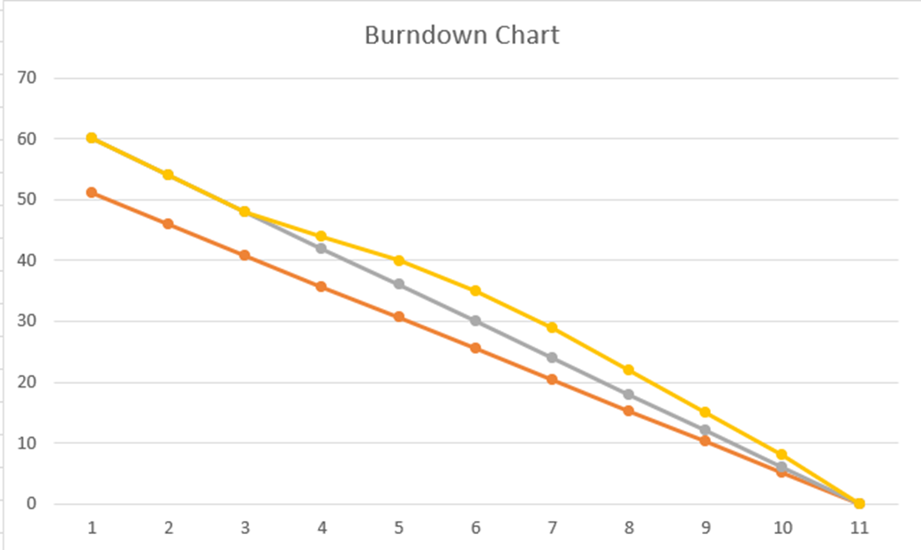

Figure 5: Burndown Chart of Sprint 1

Sprint Backlog

|  |  |  |  |  |  |
| --- | --- | --- | --- | --- | --- |
| ID | Type | Title | Status | Estimate | Spent |
| **U-1** | User Story | Sign up | Done | 20 H | 30 H |
| **U-2** | User Story | Login/Logout | Done | 30 H | 30 H |
| **U-3** | User Story | Write Diary | On hold | 10 H | 0 |
|  |  | Total |  | 60 H | 60 H |

Table 3: Sprint 1 Backlog

List of deliverables

|  |  |  |
| --- | --- | --- |
| ID | Type | Title |
| **001** | Web Page | Signup page |
| **002** | Web Page | login page |

Table 4: Sprint 1 List of Deliverables

Sprint: 2#

Date from 22/2/2022 to 9/3/2022

|  |  |  |
| --- | --- | --- |
| **Role** | **Name** | **Hours- ( Spent / Estimated)** |
| **Scrum Master** | Saleh | 28/24 |
| **Product owner** | AlMarhom | 20/24 |

Table 5: Roles of Sprint 2

Sprint Overview

|  |  |  |  |  |  |
| --- | --- | --- | --- | --- | --- |
| **Planned** | | | **Completed** | | |
| Items | Effort | Time | Items | Effort | Time |
| **3** | 34 | 48 Hours | 3 | 34 | 48 Hours |

Table 6: Sprint 2 Overview

Burndown Chart

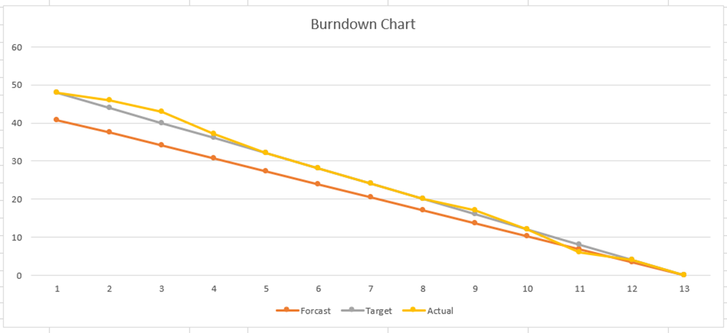

Figure 6: Burndown Chart of Sprint 2

Sprint Backlog

|  |  |  |  |  |  |
| --- | --- | --- | --- | --- | --- |
| ID | Type | Title | Status | Estimate | Spent |
| U-1 | User Story | Write Diary | Done | 20 H | 24 H |
| U-2 | User Story | Save Diary | Done | 12 H | 8 H |
| U-3 | User Story | View Old Diary | Done | 16 H | 16 H |
|  |  | Total |  | 48 H | 48 H |

Table 7: Sprint 2 Backlog

List of deliverables

|  |  |  |
| --- | --- | --- |
| ID | Type | Title |
| **001** | Web Page | Write Diary page |
| **002** | Interface | Save Diary Interface |
| **003** | Web Page | View Old Diary |

Table 8: Sprint 2 List of Deliverables

Sprint: 3#

Date from 21/3/2022 to 4/4/2022

|  |  |  |
| --- | --- | --- |
| **Role** | **Name** | **Hours- ( Spent / Estimated)** |
| **Scrum Master** | Saleh | 22/22 |
| **Product owner** | AlMarhom | 22/22 |

Table 9: Roles of Sprint 3

Sprint Overview

|  |  |  |  |  |  |
| --- | --- | --- | --- | --- | --- |
| **Planned** | | | **Completed** | | |
| Items | Effort | Time | Items | Effort | Time |
| **2** | 26 | 44 Hours | 2 | 26 | 44 Hours |

Table 10: Sprint 3 Overview

Burndown Chart

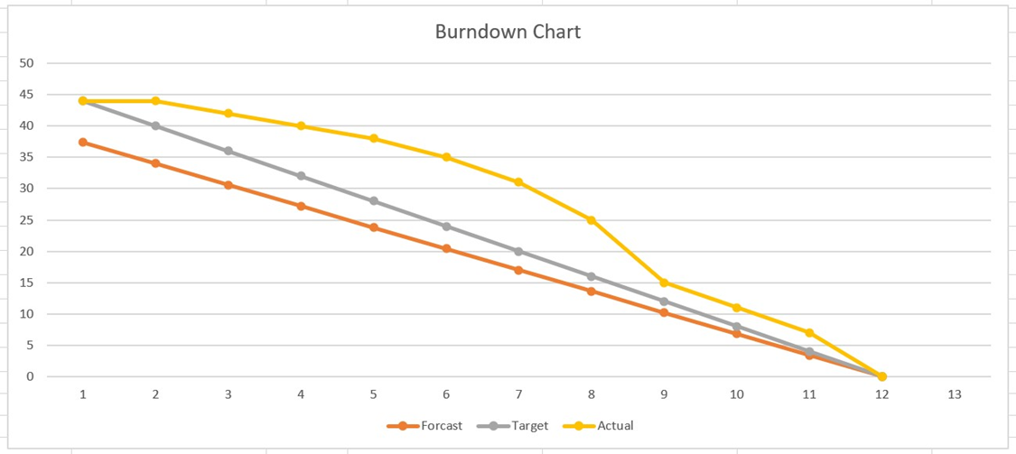

Figure 7: Burndown Chart of Sprint 3

Sprint Backlog

|  |  |  |  |  |  |
| --- | --- | --- | --- | --- | --- |
| ID | Type | Title | Status | Estimate | Spent |
| U-1 | User Story | Edit Old Diary | Done | 30 H | 35 H |
| U-2 | User Story | Search Old Diary | Done | 14 H | 9 H |
|  |  | Total |  | 44 H | 44 H |

Table 11: Sprint 3 Backlog

List of deliverables

|  |  |  |
| --- | --- | --- |
| ID | Type | Title |
| **001** | Web Page | Edit Old Diary page |
| **002** | Interface | Edit Old Diary interface |
| **003** | Interface | Search Old Diary interface |

Table 12: Sprint 3 List of Deliverables

Sprint: 4#

Date from 5/4/2022 to 18/4/2022

|  |  |  |
| --- | --- | --- |
| **Role** | **Name** | **Hours- (Spent/ Estimated)** |
| **Scrum Master** | Saleh | 22/22 |
| **Product owner** | AlMarhom | 22/22 |

Table 13: Roles of Sprint 4

Sprint Overview

|  |  |  |  |  |  |
| --- | --- | --- | --- | --- | --- |
| **Planned** | | | **Completed** | | |
| Items | Effort | Time | Items | Effort | Time |
| **2** | 40 | 44 Hours | 2 | 40 | 44 Hours |

Table 14: Sprint 4 Overview

Burndown Chart

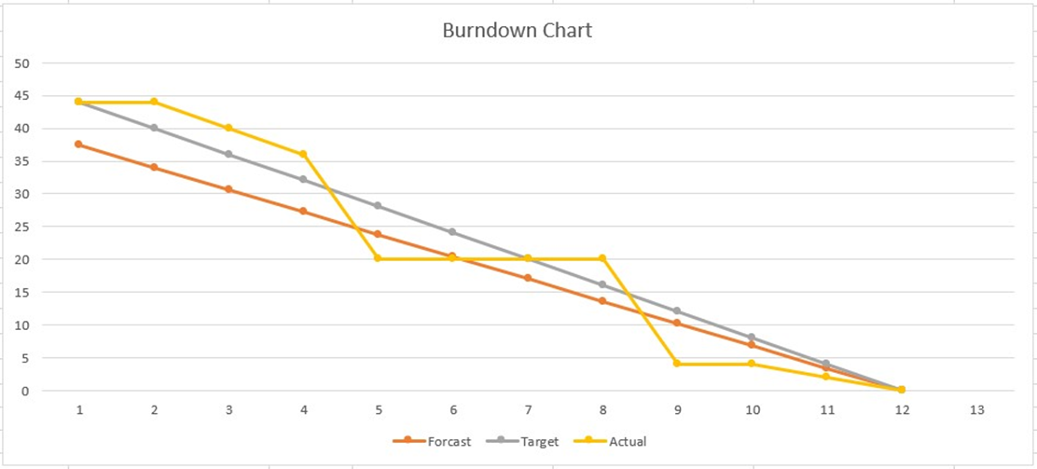

Figure 8: Burndown Chart of Sprint 4

Sprint Backlog

|  |  |  |  |  |  |
| --- | --- | --- | --- | --- | --- |
| ID | Type | Title | Status | Estimate | Spent |
| U-1 | User Story | Delete Old Diary | Done | 20 H | 12 H |
| U-2 | User Story | Sign in with Google API | Done | 24 H | 32 H |
|  |  | Total |  | 44 H | 44 H |

Table 15: Sprint 4 Backlog

List of deliverables

|  |  |  |
| --- | --- | --- |
| ID | Type | Title |
| 001 | Interface | Delete Old Diary interface |
| 002 | Interface | Sign in with Google API interface |
| 003 | Online Webhost | Project upload on infinityfree |
| 004 | API | Credential by Google cloud platform |

Table 16: Sprint 4 List of Deliverables

# Sample Code

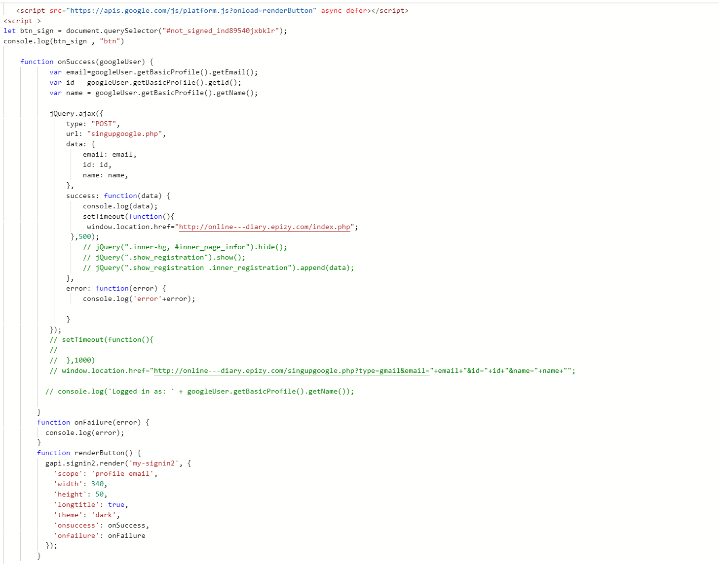

Figure 9: Sample Code of Sign in Using Google API

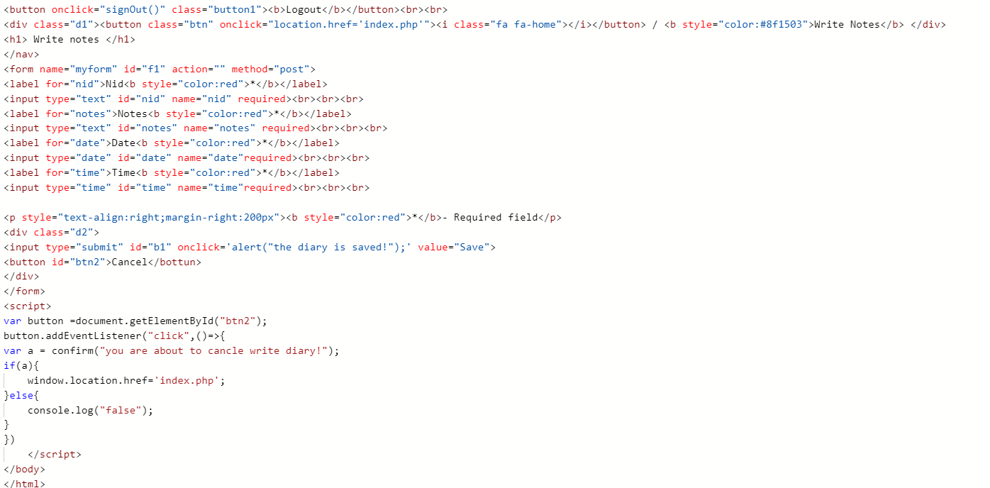

Figure 10: Sample Code of Write Notes

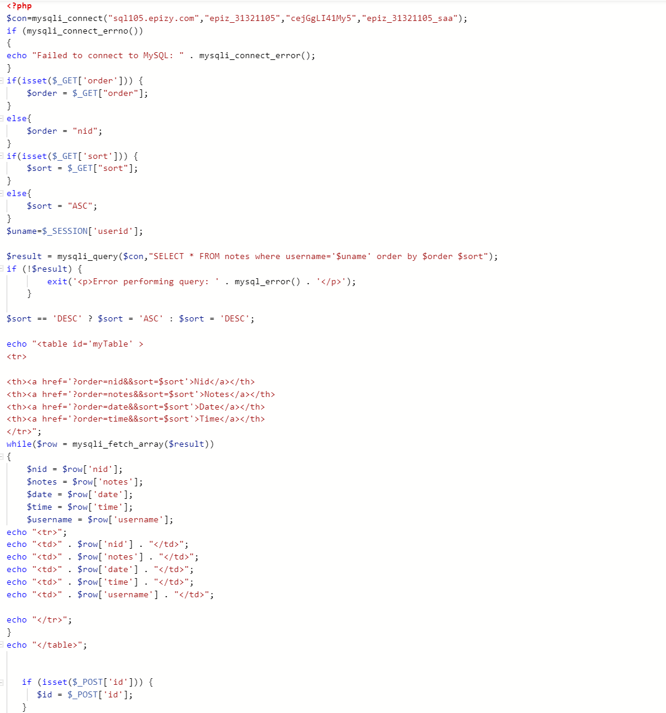

Figure 11: Sample Code of view notes

# Testing Information

We tested the features of this website using the black-box testing–testing is based on the specification of the website. It has some advantages, such as:

* Tests have lower complexity since they simply model common user behavior
* Testers do not need to learn implementation details of the system

These followings are test cases of the features from each sprint of the project

**Sprint 1**

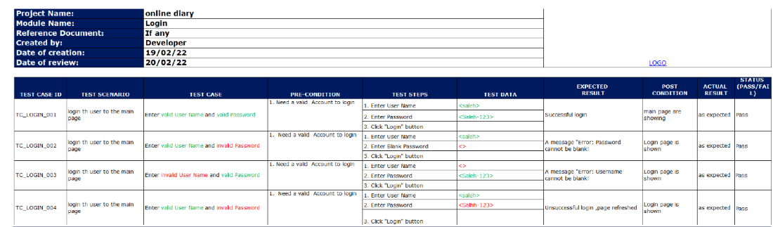

Table 17: Test Case of Login from Sprint 1

**Sprint 2**

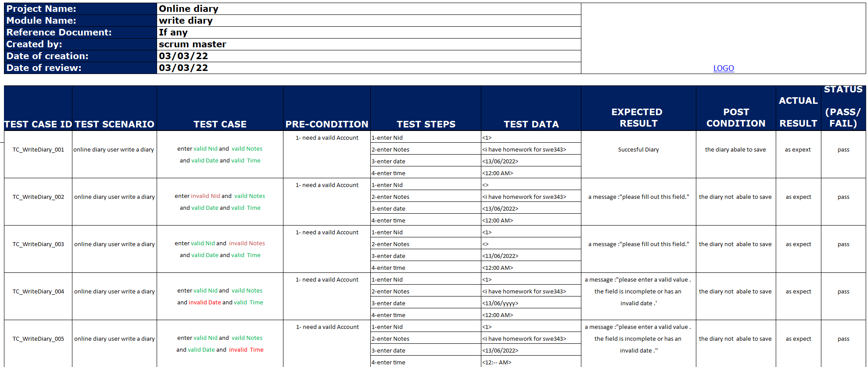

Table 18: Test Case of Write Diary from Sprint 2

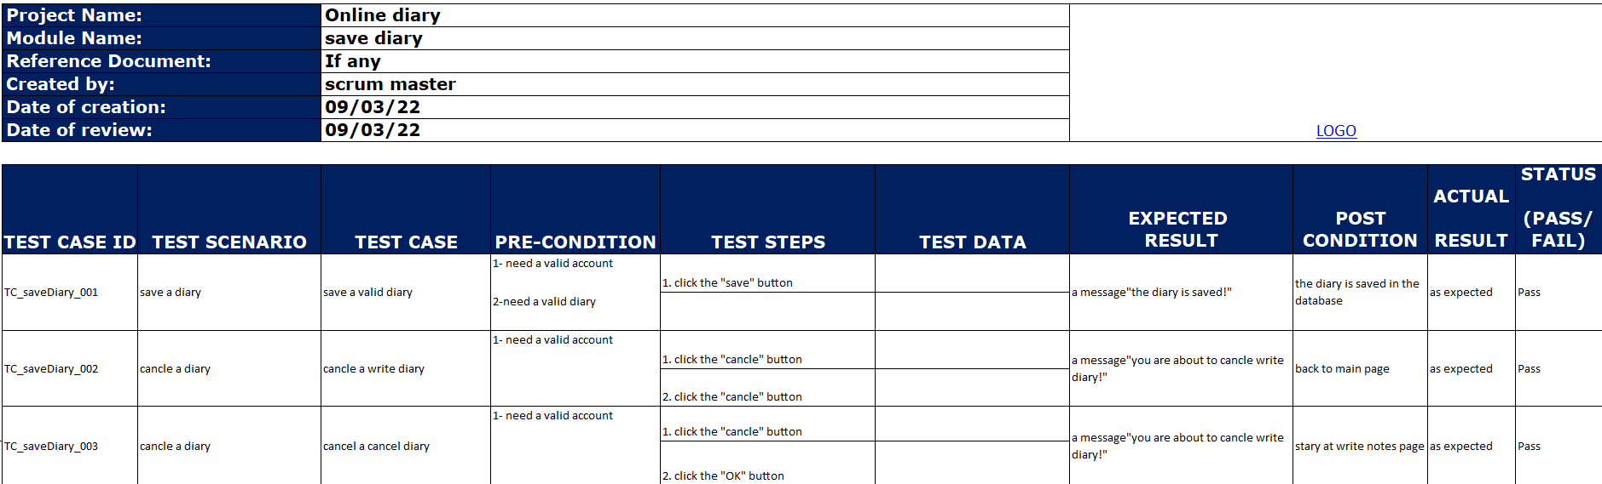

Table 19: Test Case of Save Diary from Sprint 2

**Sprint 3**

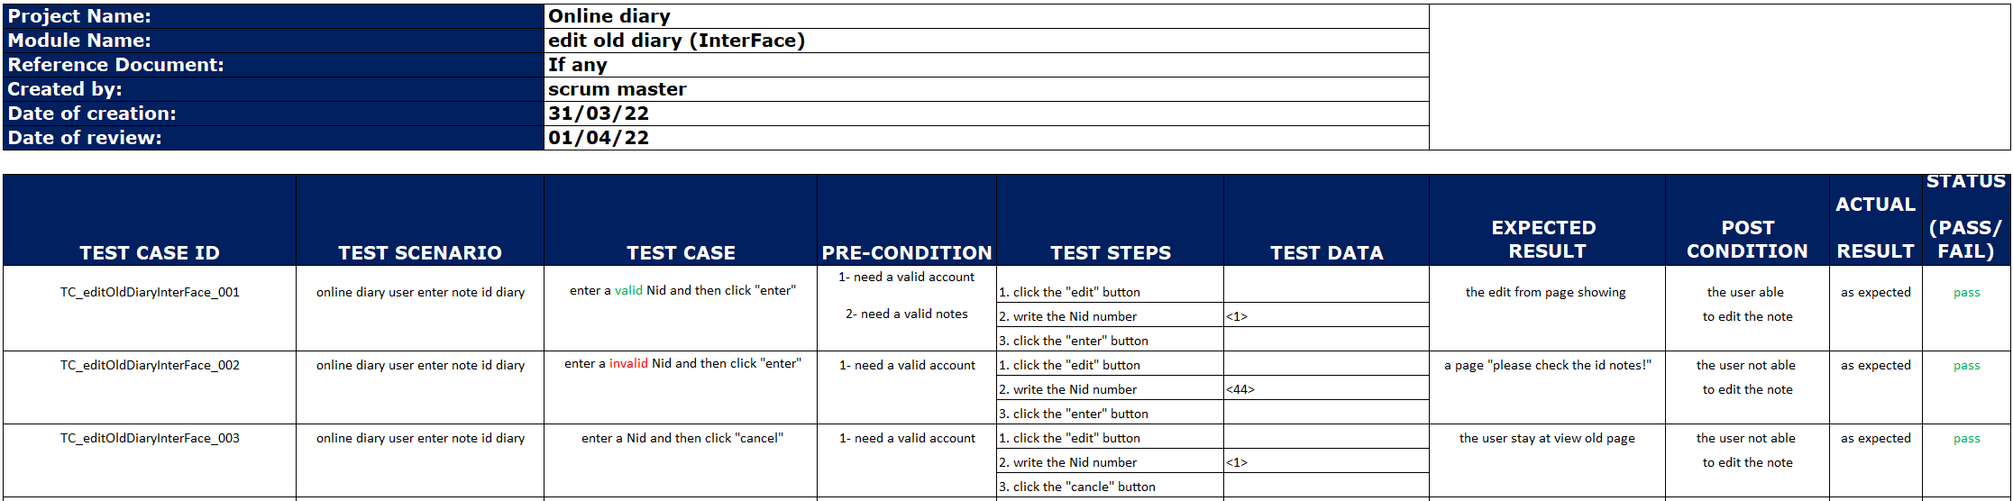

Table 20: Test Case of Edit Old Diary from Sprint 3

**Sprint 4**

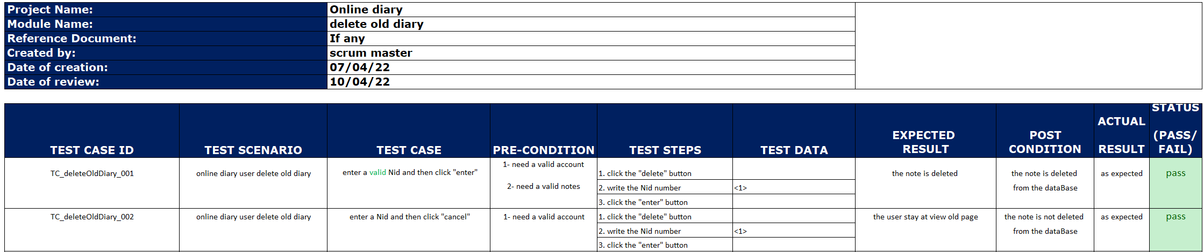

Table 21: Test Case of Delete Old Diary from Sprint 4

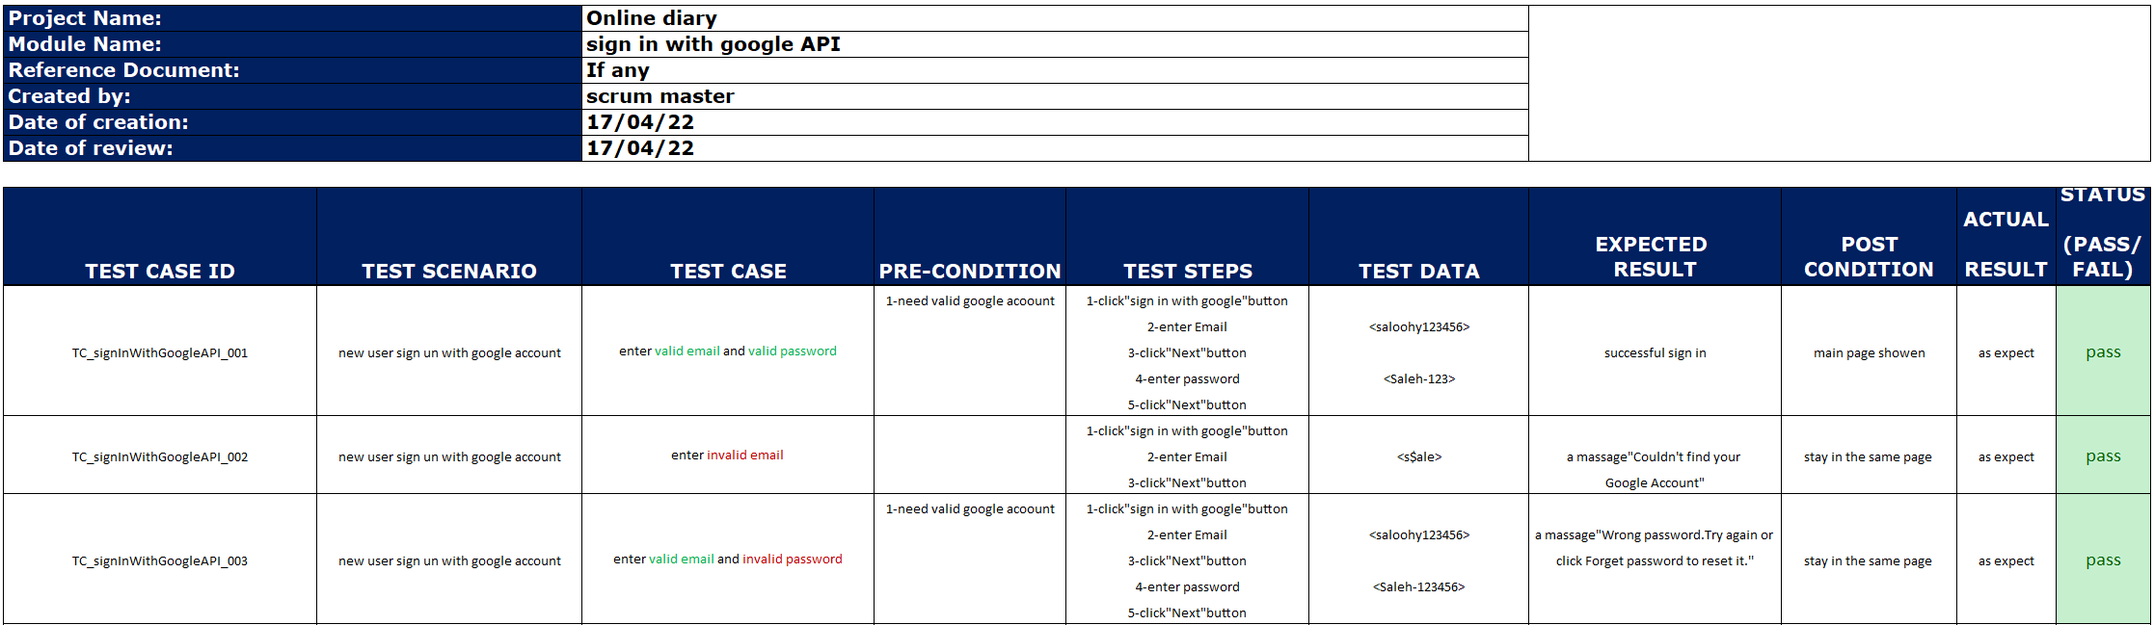

Table 22: Test Case of Sign in with Google API from Sprint 4

# 

# Deployment

http://online---diary.epizy.com/login%20page.php

Test account:

username: user

password: Saleh-123

also, u can create an account or sign in using your Google account

# Screen Shots

## Sprint Board

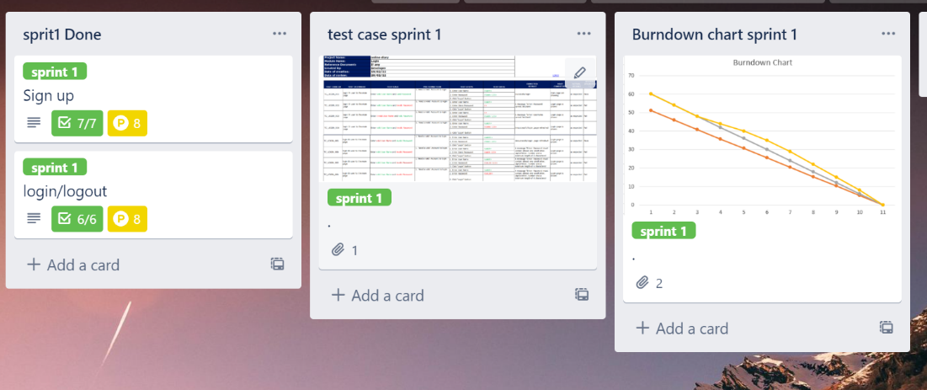

Figure 12: Board of Sprint 1

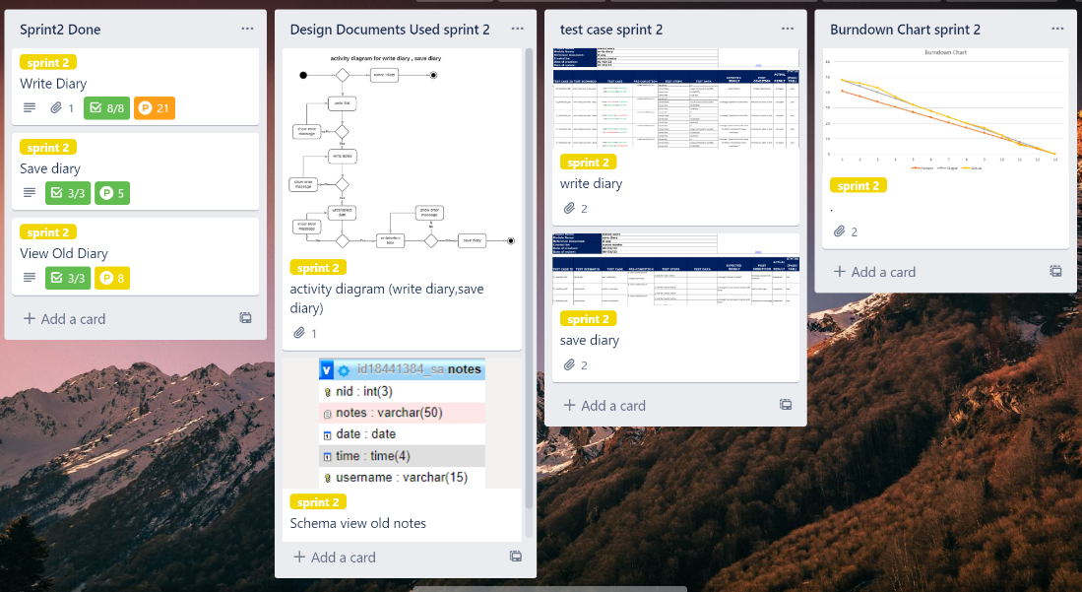

Figure 13: Board of Sprint 2

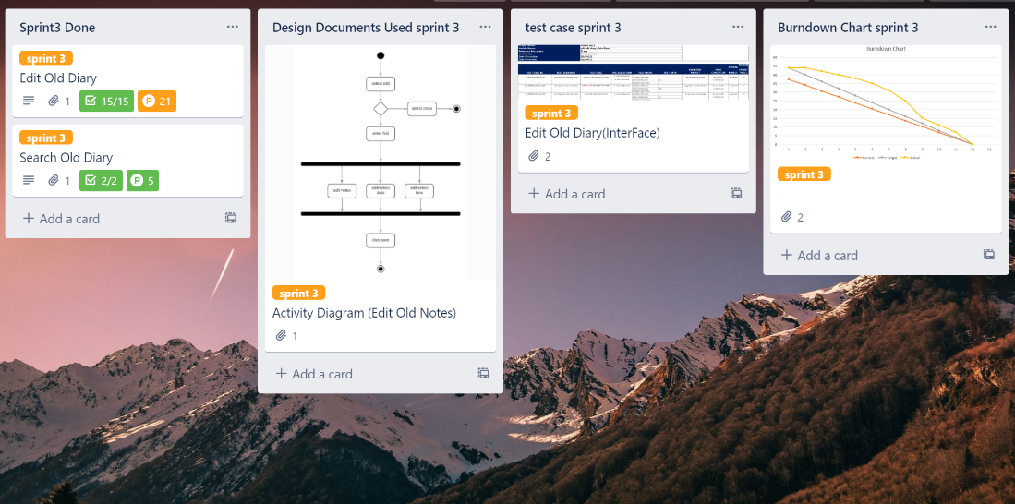

Figure 14: Board of Sprint 3

Figure 15: Board of Sprint 4

## User Interface



Figure 16: Main Page

Figure 17: Log in Page Interface